**Launch Linux machine**

-------------------------------

Create new EC2 instance with the following specifications:

* + Tag: MyLinux
  + AMI: Amazon Linux 2023
  + Instance type: t2.micro
  + Keypair: linuxKP (check .ppk)
  + Security group: LinSG
  + Number of instances: 2

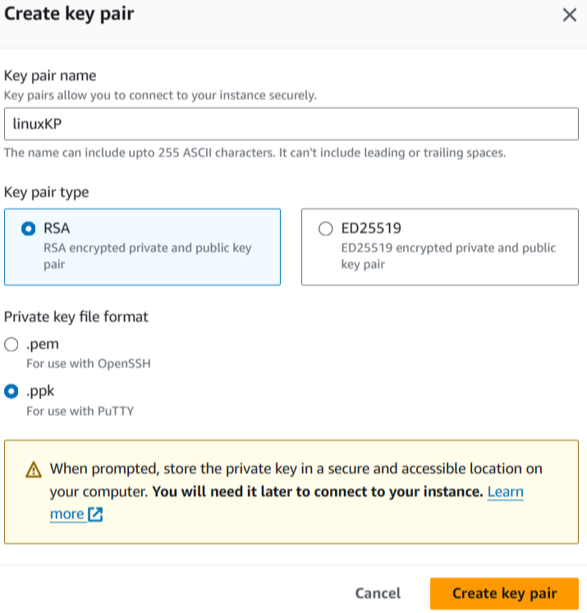

**Observation:**

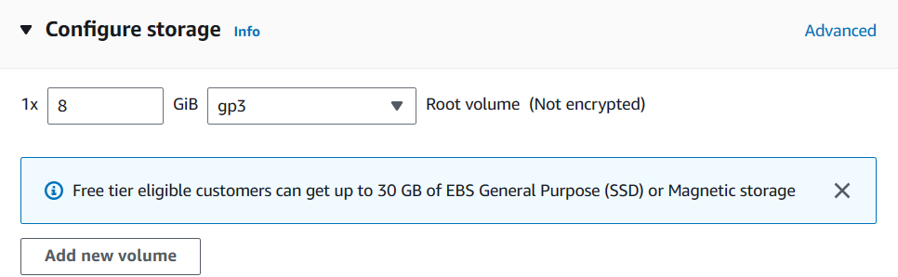

Storage (30 gb for window, 8 gb for linux)

Security Group (RDP for windows, SSH for Linux)

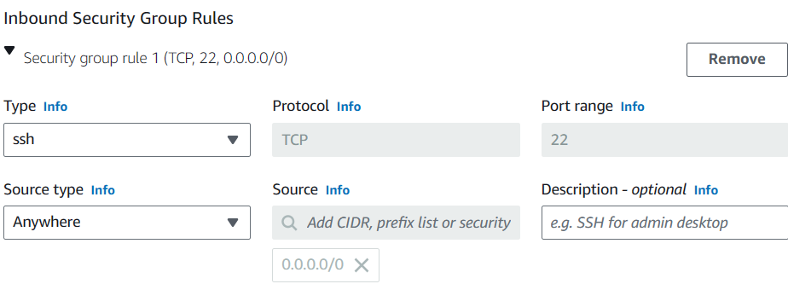

Laund and view all instances

**Observation** - Two machines created.

1. Change the hostname of each machine to MyLinux-1 and MyLinux-2

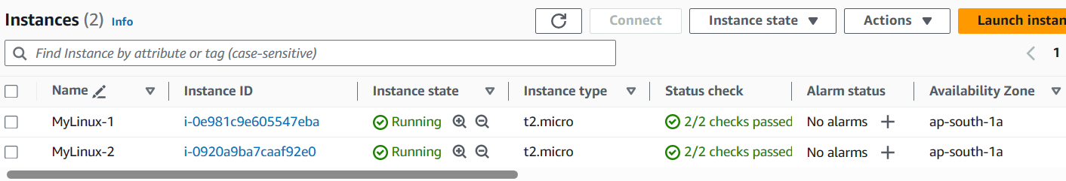

Credentials required for windows machines are (DNS, username and password)

1. Use Putty to connect to the Linux machine.
2. Putty requires ppk file (Putty private key)

If you have pem file you can convert the .pem file to a .ppk file using Puttygen.

1. Download from google using the keywords "putty and puttygen"

Open puttygen -- load -- Generate -- Save private key -- Save key without passphrase (Yes) -- Save

Visit the official PuTTY website (<https://www.putty.org/>) and download the latest version for your operating system.

Under alternate binary files

select putty.exe (64 bit)

select puttygen.exe (64 bit)

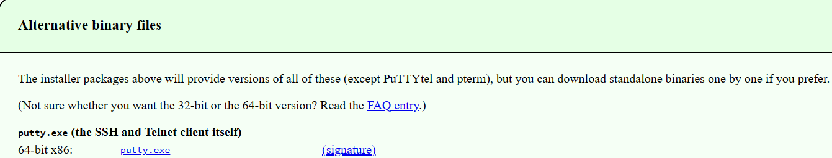

1. Launch PuTTY:

Locate and open the PuTTY application on your computer.

1. **Credentials required for putty** --

Hostname - username@dns (We get this from SSH command)

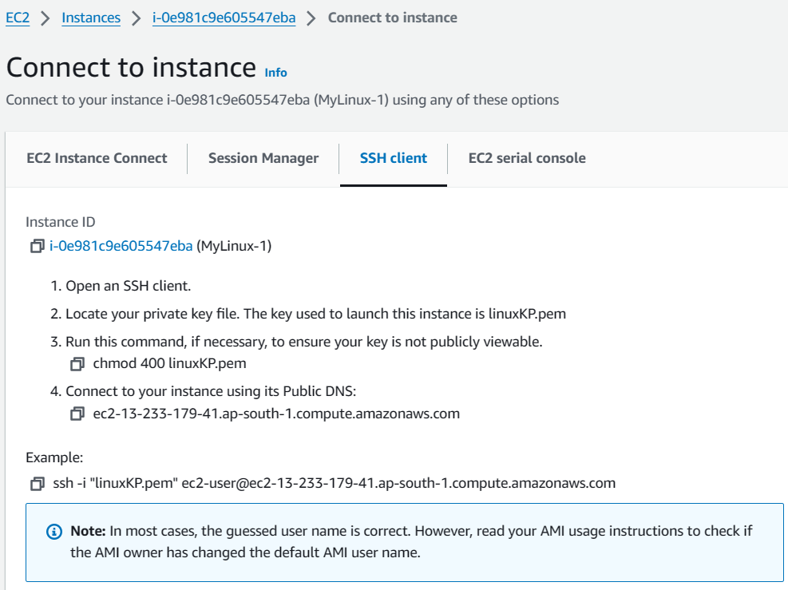

Enter Host Name or IP Address:

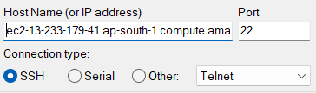

Select SSH > Auth > Credentials > browse ppk file under private key file for authentication --> Open

Username is - ec2-user (We get this from SSH command)

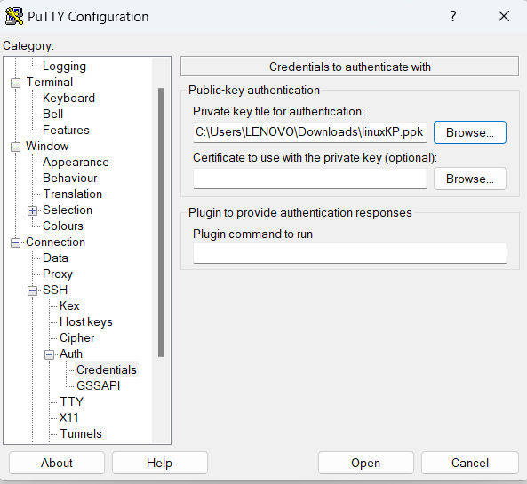

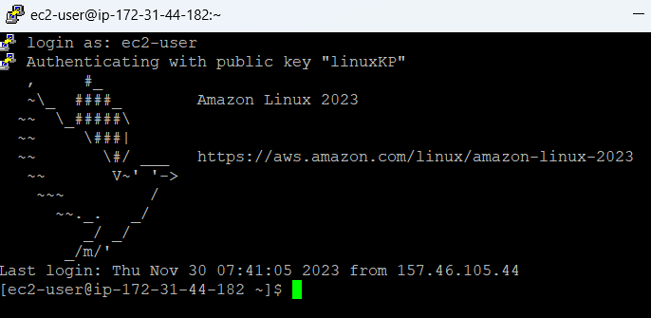

Now let’s connect to 2nd linux machine

Right click on title bar of putty -- new session -- provide details -- change colours (for easy identification)

Note: Both machines have different DNS names.

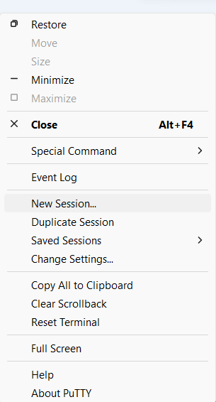

**What is a web server?**

A web server is a program that uses HTTP (Hypertext Transfer Protocol) to serve the files that make up web pages to users, in response to their requests.

Ex:

1) Apache HTTP Server

2) Internet Information Services (IIS)

3) nginx

4) httpd by Apache

**What is HTTP?**

HTTP (Hypertext Transfer Protocol) is a protocol that defines how messages are formatted and transmitted between a web server and a web client.

**What is HTTPd?**

HTTPd is a software program that runs in the background as a web server. It waits for incoming server requests and serves the hypertext and multimedia documents over the Internet using HTTP.

**What is Yum repository**

YUM Repositories are warehouses of Linux software.

Sometimes the software we want to install is not available in Linux OS default.

In such situations, we can use YUM Repositories.

We can install new software on Linux with

"yum install packagename" command from console.

**Creating a web server**

1. Install web package, it is called web server.

Package is nothing but software.

sudo su

yum update -y

yum install httpd -y

1. Create an index.html file in the /var/www/html directory.

cd /var/www/html

echo "Welcome to Linux World" > index.html

1. Start the httpd service using the following command:

service httpd start

1. Set the httpd service to start automatically whenever machine is restarted:

chkconfig httpd on

1. Test the web server by accessing the public IP address of the instance in a web browser.

Copy the public IP and paste in browser

Are we able to access the web page? No

Browser communicates using http port. We should also open http port.

Let’s open http port

IN AWS Dashboard, click on security groups

Select our security group (LinuxSG) > Inbound > Edit > Add rule

Select Type - HTTP -- Save.

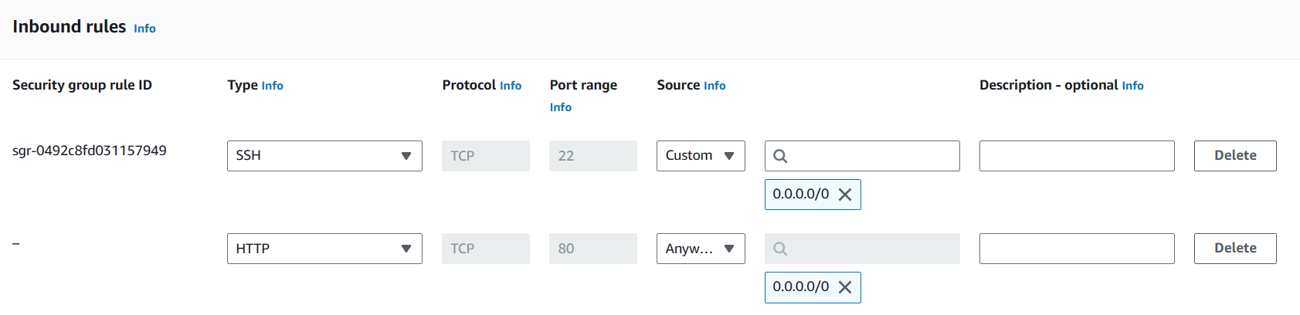

Access the public IP address of the instance in a web browser.

Are we able to access the web pages? Yes!!

**Bootstrap scripts**

When you launch an instance in Amazon EC2, you have the option of passing user data to the instance that can be used to perform common automated configuration tasks.

Under advanced details scroll down to the last, you can see user data.

Example of a bootstrap script that installs the apache web server and creates an index.html file:

